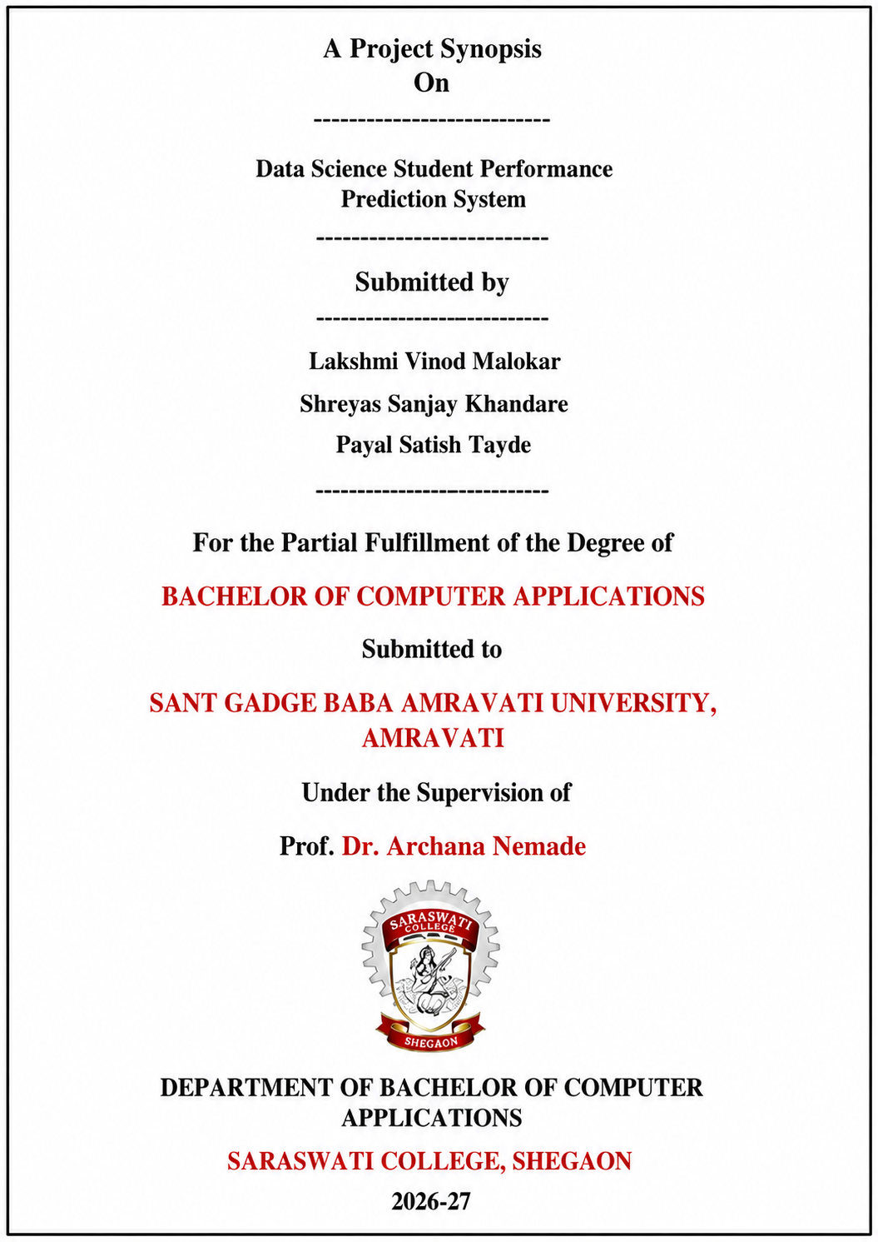

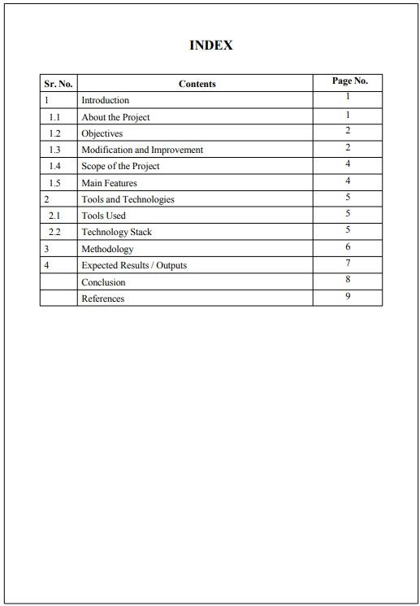

1. Introduction
In today’s digital era, the education system is continuously evolving with the integration of technology and data-driven approaches. Educational institutions generate a large amount of student data, including attendance records, internal marks, assignment scores, and previous academic performance. However, this data is often underutilized and not effectively analyzed to improve student outcomes.
Student performance evaluation is traditionally carried out after examinations, which limits the ability of educators to identify weak students at an early stage. This reactive approach makes it difficult to provide timely support and guidance to students who require improvement. As a result, many students fail to achieve their full academic potential.
To overcome these limitations, the application of Data Science and Machine Learning has become highly significant in the education sector. By analyzing historical student data, it is possible to identify patterns, relationships, and trends that influence academic performance. Predictive analytics can help forecast future outcomes and support proactive decision-making.
The proposed project, “Student Performance Prediction System,” aims to develop a data-driven solution that analyzes student data and predicts academic performance using machine learning algorithms. The system considers multiple factors such as attendance, study hours, internal marks, and previous performance to generate accurate predictions.
This project not only focuses on prediction but also emphasizes data visualization and insights generation. By presenting the results through graphs and dashboards, the system enables teachers and institutions to understand student performance more effectively.
Overall, the project demonstrates the practical implementation of data science concepts in the education domain and aims to improve academic outcomes through early identification of at-risk students and data-driven decision-making.

1.1 About the Project
The “Data Science Student Performance Prediction System” is an advanced analytical project that focuses on predicting the academic performance of students using data science and machine learning techniques. In the modern education system, institutions generate a large volume of student-related data such as attendance records, internal assessment scores, assignment performance, and previous academic results. However, this data is often stored but not effectively analyzed for improving academic outcomes.
Traditional evaluation systems mainly depend on final examinations, which provide results only after the completion of assessments. This delayed evaluation makes it difficult to identify academically weak students at an early stage. As a result, institutions fail to provide timely support and personalized guidance to improve student performance. Therefore, there is a growing need for intelligent systems that can analyze data and predict outcomes in advance.
Recent research in the field of Educational Data Mining and Learning Analytics has shown that machine learning techniques can be effectively used to predict student performance. Various studies have applied algorithms such as Decision Tree, Logistic Regression, Random Forest, and Naïve Bayes to analyze student data and achieve accurate predictions. These research works highlight that factors like attendance, study hours, internal marks, and previous academic records play a significant role in determining student success.
This project aims to utilize these data science techniques to build a predictive model that can forecast student performance before final examinations. The system will collect and preprocess student data, perform exploratory data analysis (EDA), and apply suitable machine learning algorithms to generate predictions. The model will be evaluated based on its accuracy and performance metrics.
In addition to prediction, the project also focuses on data visualization to present insights in an understandable format. Graphs, charts, and dashboards will be used to display patterns and trends in student performance. This will help teachers and educational institutions to easily interpret the results and take data-driven decisions.
The system is designed to identify at-risk students at an early stage and provide actionable insights for improvement. It also demonstrates the practical implementation of core data science concepts such as data preprocessing, feature selection, model building, and evaluation.
Overall, this project represents the integration of data science with the education domain to develop a smart and efficient system that enhances academic performance through predictive analytics and informed decision-making.

1.2 Objectives
The primary objective of this project is to develop an intelligent and data-driven system that can analyze student academic data and predict future performance using machine learning techniques. The project aims to bridge the gap between traditional evaluation methods and modern data science approaches by enabling early prediction and intervention.
One of the key objectives is to analyze student-related data such as attendance, internal marks, study hours, and previous academic records to identify patterns and relationships that influence performance. Through exploratory data analysis, the project seeks to understand how different factors contribute to student success or failure.
Another important objective is to design and implement a predictive model using machine learning algorithms. Based on insights from existing research in educational data mining, algorithms such as Decision Tree and Logistic Regression will be applied to predict whether a student is likely to pass or fail or achieve a certain grade. The model will be evaluated using performance metrics to ensure accuracy and reliability.
The project also aims to provide meaningful data visualization to present the analysis results in a clear and understandable format. Charts, graphs, and dashboards will be used to represent trends and patterns, making it easier for educators to interpret the data and make informed decisions.
In addition, the system aims to support early identification of at-risk students. By predicting performance in advance, teachers can take proactive measures such as providing additional support, personalized learning strategies, and continuous monitoring to improve academic outcomes.
Another objective is to demonstrate the practical implementation of data science concepts such as data preprocessing, feature selection, model building, and evaluation. This will showcase the application of theoretical knowledge to solve real-world problems in the education domain.
Finally, the project aims to create a scalable and extendable solution that can be further enhanced with advanced machine learning models, real-time data integration, and deployment as a web-based system in the future.

1.3 Modification and Improvement
The proposed Student Performance Prediction System introduces significant improvements over the traditional methods of evaluating student performance. Existing systems in most educational institutions primarily rely on manual observation and final examination results, which provide only a limited and delayed understanding of student progress. These systems are not capable of analyzing multiple influencing factors together and lack predictive capabilities.
One of the major modifications in the proposed system is the integration of data science techniques for analyzing student data. Unlike traditional systems that consider only marks, this project incorporates multiple parameters such as attendance, study hours, internal assessments, and previous academic performance. This multidimensional approach provides a more accurate and comprehensive analysis of student performance.
Another important improvement is the use of machine learning algorithms for prediction. Based on insights from existing research in educational data mining, the system applies algorithms such as Decision Tree and Logistic Regression to predict student outcomes in advance. This predictive capability transforms the system from a reactive approach to a proactive one, enabling early identification of students who are at risk of poor performance.
The project also enhances the usability of the system through data visualization. Traditional systems present data in raw or tabular form, which is difficult to interpret. In contrast, the proposed system uses graphs, charts, and dashboards to represent data visually, making it easier for teachers and institutions to understand patterns and trends.
In addition, the system improves efficiency and accuracy by automating data processing and analysis. Manual evaluation is often time-consuming and prone to human errors, whereas the proposed system ensures faster processing and more reliable results.
Furthermore, the system is designed to be scalable and flexible. It can be extended in the future by integrating advanced machine learning models, real-time data collection, and deployment as a web or mobile-based application. This makes the project not only useful for academic purposes but also adaptable for real-world implementation.
Overall, the proposed system significantly improves upon existing methods by introducing automation, predictive analytics, data visualization, and a data-driven approach, thereby enhancing the effectiveness of student performance evaluation.

1.4 Scope of the Project
The scope of the “Data Science Student Performance Prediction System” is focused on analyzing student academic data and predicting their performance using data science and machine learning techniques. The project covers the complete process of data handling, including data collection, preprocessing, analysis, model development, and result visualization.
The system is designed to work with structured student data such as attendance records, internal assessment marks, study hours, and previous academic performance. By using this data, the system aims to identify patterns and relationships that influence student outcomes and generate predictions regarding their future performance.
The project includes the implementation of machine learning algorithms such as Decision Tree and Logistic Regression to build a predictive model. It also incorporates exploratory data analysis (EDA) to understand trends and key influencing factors. Additionally, the project provides visualization through charts and dashboards, making the analysis easy to interpret for users such as teachers and institutions.
However, the scope of the project is limited to offline or static datasets and does not include real-time data integration from live educational systems. The system is developed as a prototype to demonstrate the practical application of data science in the education domain. It does not include features like live student tracking, automated data entry, or full-scale deployment in institutional environments.
Despite these limitations, the project has strong potential for future expansion. It can be extended by integrating real-time databases, advanced machine learning models, and deployment as a web or mobile application. It can also be enhanced by incorporating additional factors such as behavioral data, extracurricular activities, and psychological parameters for more accurate predictions.
Overall, the scope of this project is to provide a foundational and scalable solution that demonstrates how data science can be effectively used to improve student performance analysis and support data-driven decision-making in education.

1.5 Main Features
The proposed Student Performance Prediction System includes several important features that make it efficient, intelligent, and useful for academic analysis and prediction.
One of the key features of the system is data collection and preprocessing. The system is capable of handling student-related data such as attendance, internal marks, study hours, and previous academic records. It performs data cleaning and preprocessing to remove missing values and inconsistencies, ensuring that the dataset is accurate and ready for analysis.
Another major feature is exploratory data analysis (EDA). The system analyzes the dataset to identify patterns, trends, and relationships between different factors affecting student performance. This helps in understanding how various parameters influence academic outcomes.
The system also includes machine learning-based prediction. It uses algorithms such as Decision Tree and Logistic Regression to build a predictive model that can forecast student performance. This feature enables early identification of students who are at risk of poor academic results.
Data visualization is another important feature of the system. The results of the analysis and predictions are presented through graphs, charts, and dashboards. This makes it easier for users to interpret complex data and gain meaningful insights.
The system provides performance insights and reporting. It generates outputs such as predicted results (pass/fail or grade) and analytical reports, which can be used by teachers and institutions for decision-making.
Automation is a key feature that improves efficiency. The system reduces manual effort by automating data processing, analysis, and prediction, making the overall process faster and more reliable.
Finally, the system is designed to be scalable and flexible. It can be extended in the future by integrating real-time data, advanced machine learning models, and deployment as a web or mobile application.

2. Tools and Technologies

The development of the “Data Science Student Performance Prediction System” requires a combination of tools and technologies that support data analysis, machine learning, and visualization. These tools are selected based on their efficiency, ease of use, and suitability for handling data science tasks.
The primary tool used in this project is Jupyter Notebook or Google Colab, which provides an interactive environment for writing and executing Python code. These platforms allow efficient implementation of data preprocessing, analysis, and machine learning models in a step-by-step manner. They are widely used in the data science field due to their flexibility and support for visualization.
For data storage and management, structured datasets in CSV format are used, and optionally, MySQL can be integrated to handle larger datasets. These datasets contain student-related information such as attendance, marks, and study hours, which are used as input for analysis and prediction.
The project is implemented using Python as the core programming language because of its simplicity and extensive support for data science and machine learning. Python offers powerful libraries that make it easier to perform complex data operations and build predictive models.
For data analysis, libraries such as Pandas and NumPy are used. Pandas is helpful for data manipulation, cleaning, and transformation, while NumPy is used for numerical computations. These libraries play a crucial role in preparing the dataset for further analysis.
For data visualization, Matplotlib and Seaborn libraries are used to create graphs and charts. These visualizations help in understanding patterns, trends, and relationships within the data, making it easier to interpret results.
Machine learning algorithms are implemented using the Scikit-learn library. This library provides various models such as Decision Tree and Logistic Regression, which are used to build and evaluate the prediction system. It also offers tools for model training, testing, and performance evaluation.
Additionally, Power BI is used for creating interactive dashboards and reports. It helps in presenting the analyzed data in a visually appealing and user-friendly format, which is useful for decision-making.
Overall, the combination of these tools and technologies enables the development of an efficient, scalable, and data-driven system for predicting student performance.

2.1 Tools Used
The development of the Student Performance Prediction System involves the use of several important tools that support data processing, analysis, and visualization. One of the primary tools used in this project is Jupyter Notebook or Google Colab, which provides an interactive environment for writing and executing Python code. These tools are widely used in data science because they allow step-by-step execution, easy debugging, and integration of code with visual outputs such as graphs and charts.
For data handling, datasets are stored in CSV (Comma Separated Values) format, which is simple and efficient for managing structured data. These files contain student-related information such as attendance, marks, and study hours, which are used as input for the system. In addition, MySQL can be optionally used as a database tool to store and manage large volumes of data in a structured manner.
For data visualization and reporting, Power BI is used as an important tool. It helps in creating interactive dashboards and graphical reports that make it easier to understand patterns and insights from the data. Visualization plays a key role in presenting the results in a clear and user-friendly way.
Overall, these tools provide a strong foundation for developing the system by enabling efficient data handling, analysis, and visualization, making the project practical and effective.

2.2 Technology Stack
The Student Performance Prediction System is developed using a well-structured technology stack that supports data analysis, machine learning, and visualization. The primary programming language used in this project is Python, which is widely preferred in the field of data science due to its simplicity, readability, and extensive library support.
For data analysis and manipulation, libraries such as Pandas and NumPy are used. Pandas is mainly used for handling datasets, performing data cleaning, transformation, and analysis, while NumPy is used for numerical computations and efficient handling of large data arrays. These libraries play a crucial role in preparing the dataset for further processing.
For data visualization, Matplotlib and Seaborn libraries are used. These tools help in creating graphs and charts such as bar charts, line graphs, and heatmaps, which are useful for understanding patterns and relationships within the data. Visualization makes it easier to interpret complex data and derive meaningful insights.
Machine learning algorithms are implemented using the Scikit-learn library. This library provides various models such as Decision Tree and Logistic Regression, which are used to build the prediction system. It also includes tools for training, testing, and evaluating the model performance based on accuracy and other metrics.
Additionally, Power BI is used as a visualization tool to create interactive dashboards and reports. It helps in presenting the final results in a visually appealing and user-friendly manner, which supports better decision-making.
Overall, this technology stack provides a strong and efficient framework for developing a data-driven system that can analyze student data and predict academic performance accurately.

3. Methodology
The methodology of the Student Performance Prediction System follows a structured and systematic approach to develop an efficient and accurate prediction model using data science techniques. The entire process is divided into multiple stages, starting from data collection to final prediction and visualization.
The first step in the methodology is data collection. In this stage, the dataset containing student-related information such as attendance, internal marks, study hours, and previous academic performance is collected. The data can be obtained from publicly available sources such as Kaggle or created manually for academic purposes.
The next step is data preprocessing. Raw data often contains missing values, inconsistencies, and irrelevant information. Therefore, data cleaning is performed to handle missing values, remove duplicates, and ensure data consistency. This step is important to improve the quality of the dataset and ensure accurate analysis.
After preprocessing, exploratory data analysis (EDA) is performed. In this stage, the dataset is analyzed using statistical methods and visualization techniques to identify patterns, trends, and relationships between variables. Graphs and charts are used to understand how different factors affect student performance.
The next step is feature selection, where important attributes that have a significant impact on student performance are selected. This helps in improving the efficiency and accuracy of the machine learning model by removing unnecessary data.
Once the features are selected, the dataset is divided into training and testing sets. The training data is used to build the model, while the testing data is used to evaluate its performance.
In the model building stage, machine learning algorithms such as Decision Tree and Logistic Regression are applied to train the model. These algorithms analyze the data and learn patterns that can be used to predict student performance.
After building the model, model evaluation is performed using performance metrics such as accuracy. This step ensures that the model is reliable and provides correct predictions.
Finally, the results are presented using data visualization techniques. Charts, graphs, and dashboards are created to display the predictions and insights in an easy-to-understand format. The system outputs the predicted performance of students, such as pass/fail or grade classification.
Overall, this methodology ensures a complete workflow from data collection to prediction and visualization, making the system efficient, accurate, and practical for real-world applications.

4. Expected Results / Outputs
The expected result of the Student Performance Prediction System is to develop an efficient and accurate model that can predict student academic performance based on historical data. The system will analyze various input parameters such as attendance, study hours, internal marks, and previous academic records to generate meaningful predictions.
One of the primary outputs of the system will be the prediction of student performance in terms of categories such as pass/fail or grade classification. This prediction will help in identifying students who are at risk of poor academic performance at an early stage, allowing teachers to take corrective actions in a timely manner.
Another important output of the system is data visualization. The project will generate graphical representations such as bar charts, line graphs, and heatmaps to display patterns and relationships in student data. These visualizations will make it easier to understand trends and support better decision-making.
The system will also provide analytical insights by highlighting key factors that influence student performance. For example, it may show how attendance or study hours impact academic results. These insights will help educators in improving teaching strategies and student engagement.
Additionally, the project will produce performance evaluation results of the machine learning model, including accuracy and other relevant metrics. This will demonstrate the reliability and effectiveness of the predictive model.
Overall, the expected outcome is a complete data-driven system that not only predicts student performance but also provides clear insights and visual reports, making it a useful tool for students, teachers, and educational institutions.

Conclusion
The Student Performance Prediction System demonstrates the effective application of data science and machine learning techniques in the education domain. The project successfully analyzes student data and predicts academic performance based on key factors such as attendance, study hours, and previous results.
Through this system, it becomes possible to identify at-risk students at an early stage and provide timely support to improve their academic outcomes. The use of data visualization further enhances the understanding of performance trends and patterns, enabling better decision-making for educators and institutions.
The project also highlights the importance of data-driven approaches over traditional methods, offering improved accuracy, efficiency, and insights. It showcases the practical implementation of core concepts such as data preprocessing, exploratory data analysis, and model building.
Overall, the system serves as a valuable tool for improving student performance and demonstrates the potential of data science in transforming the education system. It can be further enhanced and expanded for real-world implementation in the future.

References
- Yağcı, M. (2022). Educational Data Mining: Prediction of Students’ Academic Performance. Springer Journal.
- Rakhunde, A., et al. (2023). Student Performance Prediction System Using Machine Learning. International Journal of Novel Research and Development (IJNRD).
- Adane, M. D., et al. (2023). Performance Analysis of Machine Learning Algorithms in Student Prediction. Journal of Advances in Mathematics and Computer Science.
- Bilal, M., et al. (2022). Role of Demographic and Academic Features in Student Performance Prediction. Nature Scientific Reports.
- Han, J., Kamber, M., & Pei, J. (2011). Data Mining: Concepts and Techniques. Morgan Kaufmann Publishers.
- Pedregosa, F., et al. (2011). Scikit-learn: Machine Learning in Python. Journal of Machine Learning Research.
- Python Software Foundation. (2024). Python Documentation.
- Kaggle. (2024). Student Performance Dataset.

